**Assignment 3**

**Problem 1**

Use the graphical method to solve the problem:

Please use IOR Tutorial Graphical Analysis. Cut and Paste the computer-generated results, as shown in the assignment guidance. Hand-drawn graphs or graphs generated within Excel or any other software package other than IOR Tutorial will not receive credit.

Make sure you provide the optimal values for x1*, x2*, and Z* and clearly label the objective function and each constraint in the Graph.

Maximize Z = 4 x1 + 2 x2

Subject to

0.5 x2 ≤ 5

2 x1 + 5 x2 ≤ 60

3 x1 + 3 x2 ≤ 54

3 x1 + x2 ≤ 44

and

x1 ≥ 0, x2 ≥ 0

**Problem 2**

The Whitt Window Company, a company with only three employees, makes two different kinds of hand-crafted windows: wood-framed and aluminum-framed windows. The company earns $150 profit for each wood-framed window and $75 profit for each aluminum-framed window. Doug makes wood frames and can make six per day. Linda makes aluminum frames and can make four per day. Bob forms and cuts the glass and can make 24 square feet of glass per day. Each wood-framed window uses 3 square feet of glass and each aluminum-framed window uses 4 square feet of glass.

The company wishes to determine how many windows of each type to produce per day to maximize total profit.

1. Construct and fill in a table like Table 3.1 for this problem, identifying both the activities and the resources.

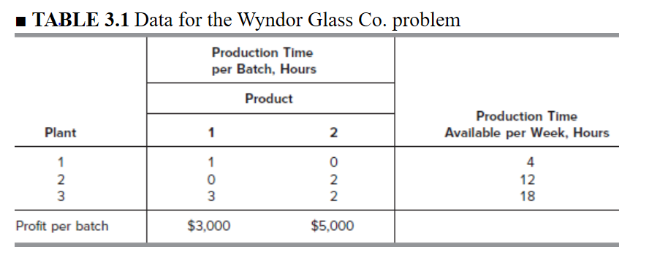

1. Formulate a linear programming model for this problem (i.e., define the objective function, decision variables, and functional and non-negative constraints).
2. Use the graphical analysis in the IOR Tutorial to solve this model.
3. A new competitor in town has started making wood-framed windows as well. This may force the company to lower the price they charge and so lower the profit made for each wood-framed window. How would the optimal solution change (if at all) if the profit per wood-framed window decreases from $300 to $200? From $300 to 100? (Use the Graphical Analysis and Sensitivity Analysis procedure in IOR Tutorial.). Do not just show the numbers, provide written answers to the questions using the results.
4. Doug is considering lowering his working hours, which would decrease the number of wood frames he makes per day. How would the optimal solution change if he makes only five wood frames per day? (Use the Graphical Analysis and Sensitivity Analysis procedure in IOR Tutorial Do not just show the numbers, provide written answers to the questions using the results.

**Problem 3**

The following table summarizes the key facts about two products, A and B, and the resources, Q, R, and S, required to produce them.



All the assumptions of linear programming hold.

1. Formulate a linear programming model for this problem.
2. Solve this model graphically using the IOR Tutorial graphical analysis.
3. Verify the exact value of your optimal solution from part (b) by solving algebraically for the simultaneous solution of the relevant two equations.